1.Please see the picture(①), which is the PlatformIO plugin, and then click ② Open Project to open the project.

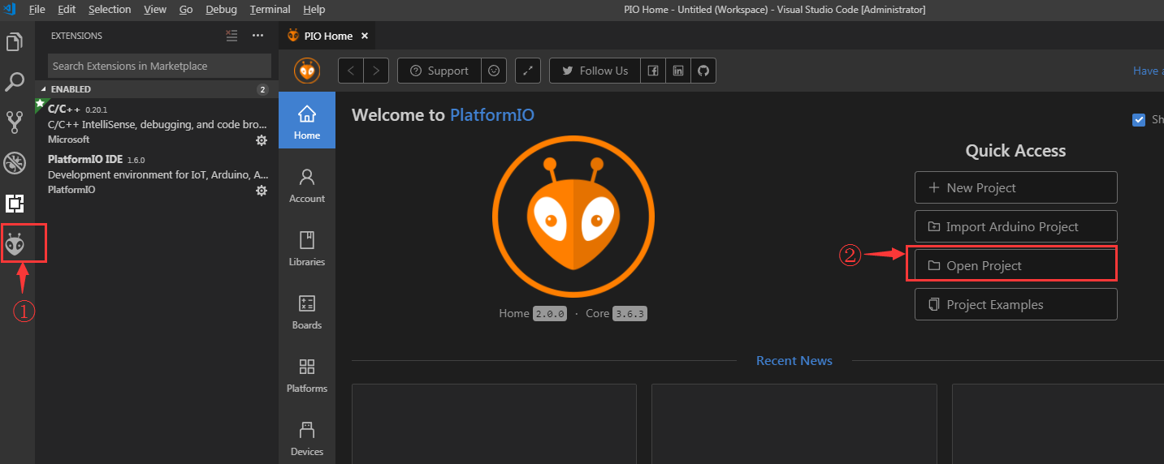

Find the BIGTREETECH TFT35 firmware source directory , then click Open

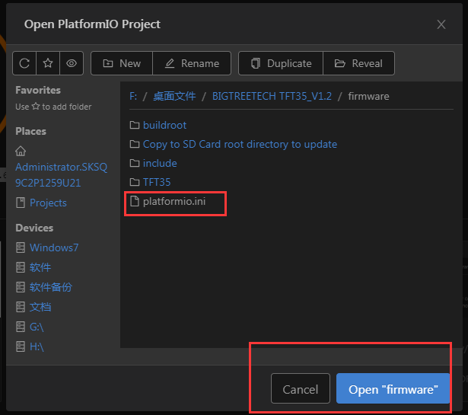

After opening the project, go to the platformio.ini file and change the default environment .

the “env_default” can be “BIGTREE_TFT35_V1_2”, “BIGTREE_TFT35_V1_1”, and “BIGTREE_TFT35_V1_0”

it depends on your hardware.

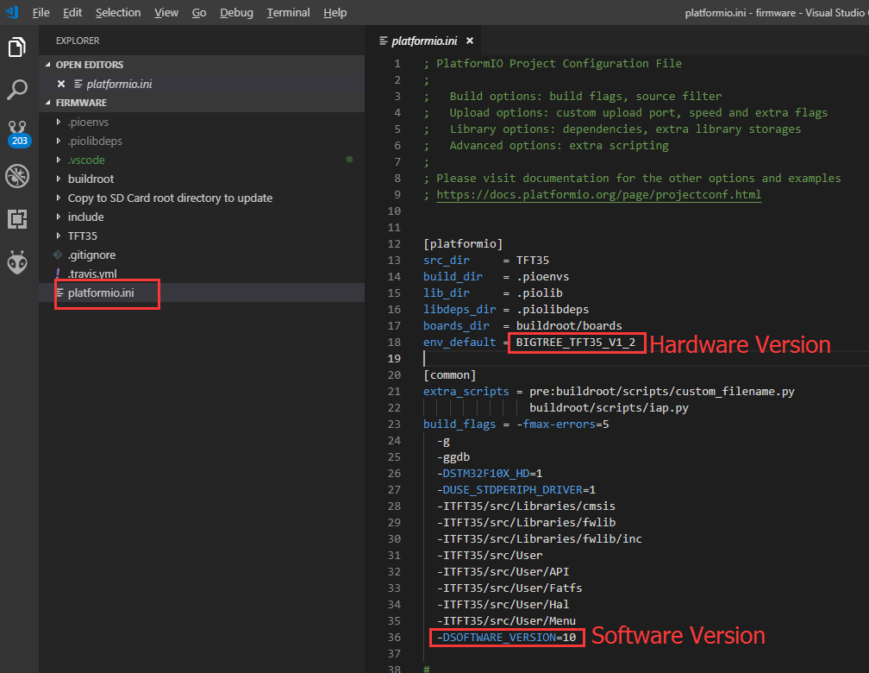

After the modification is complete, press Ctrl+Alt+B, and platformio will automatically download the compiled component and compile it.

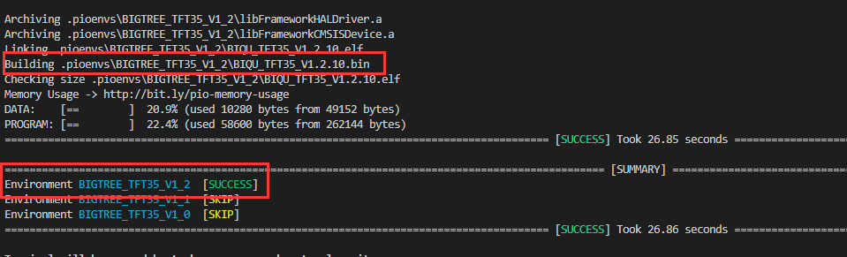

After the compilation is successful, a BIQU_TFT35_V1.x.x.bin file will be generated in the .pioenvs\BIGTREE_TFT35_V1_x directory. We need copy this file to the SD card, and insert this SD Card to TFT35 Touch Screen, then reset the Touch Screen, the firmware will be updated automatically.